CEN4010 Principles of Software Engineering

Spring 2018

Milestone 3: More Detailed Requirements, Architecture and a Vertical Software Prototype – Instructions

Group 9: Hardware Nanny

Alicia Mitchell (amitch41@fau.edu)

Sergio Ramirez

Bradley Rubenstein

Guimel Gonzalez Hernandez

Ryan Juraidini

Date of Modification: Monday March. 26th, 2018

Vertical Software Prototype User Instructions

Feature Created: Add an Item to the Inventory

1. **Go to the Hardware Nanny Site**

<http://lamp.cse.fau.edu/~CEN4010_S2018g09/M3/index.php>

**Vertical Slice Video Demo:**

<https://youtu.be/csQxEZV6aQo>

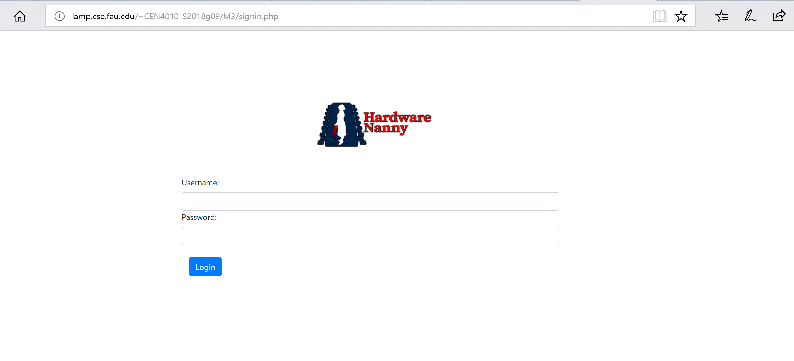

1. **Login Credentials**

Username: test1

Password: test1

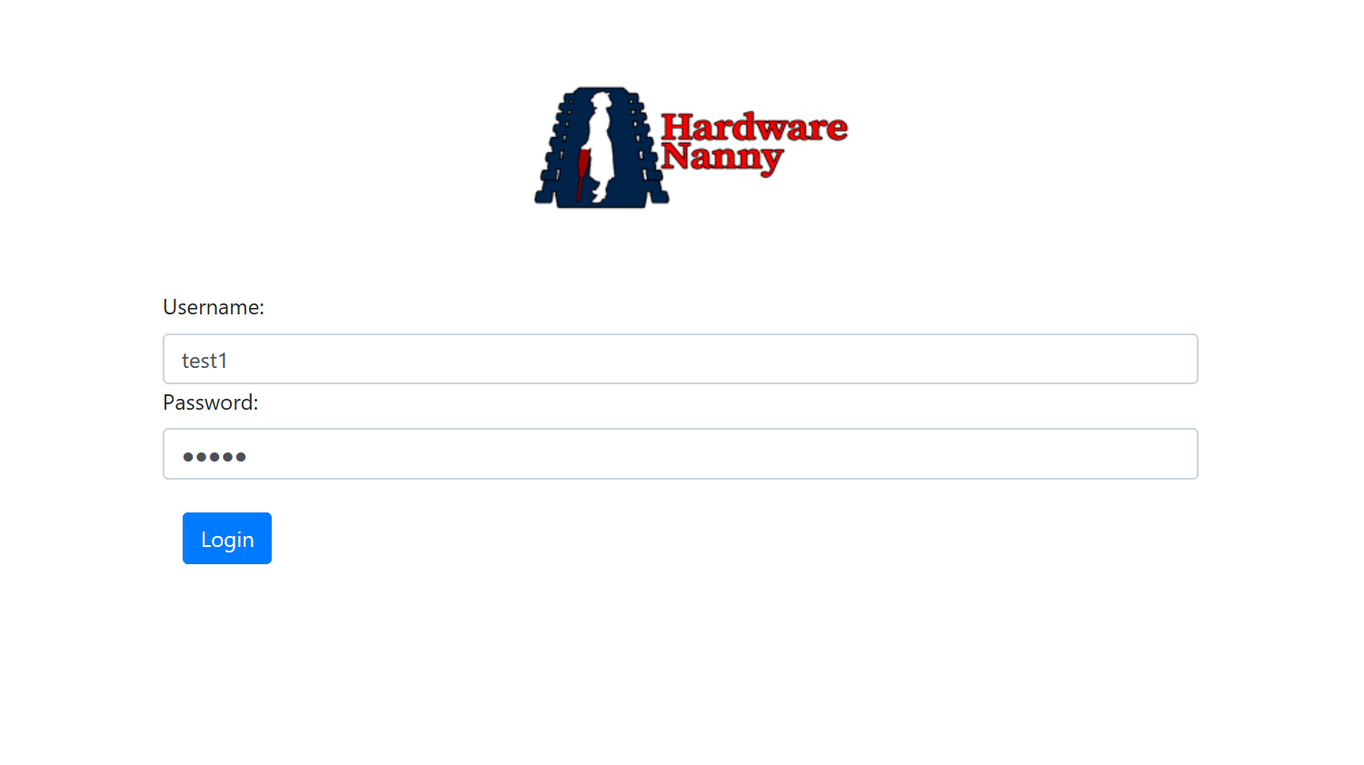

1. **Arrive at Landing Page**
2. Click on **Inventory** on the top left options bar on the landing page

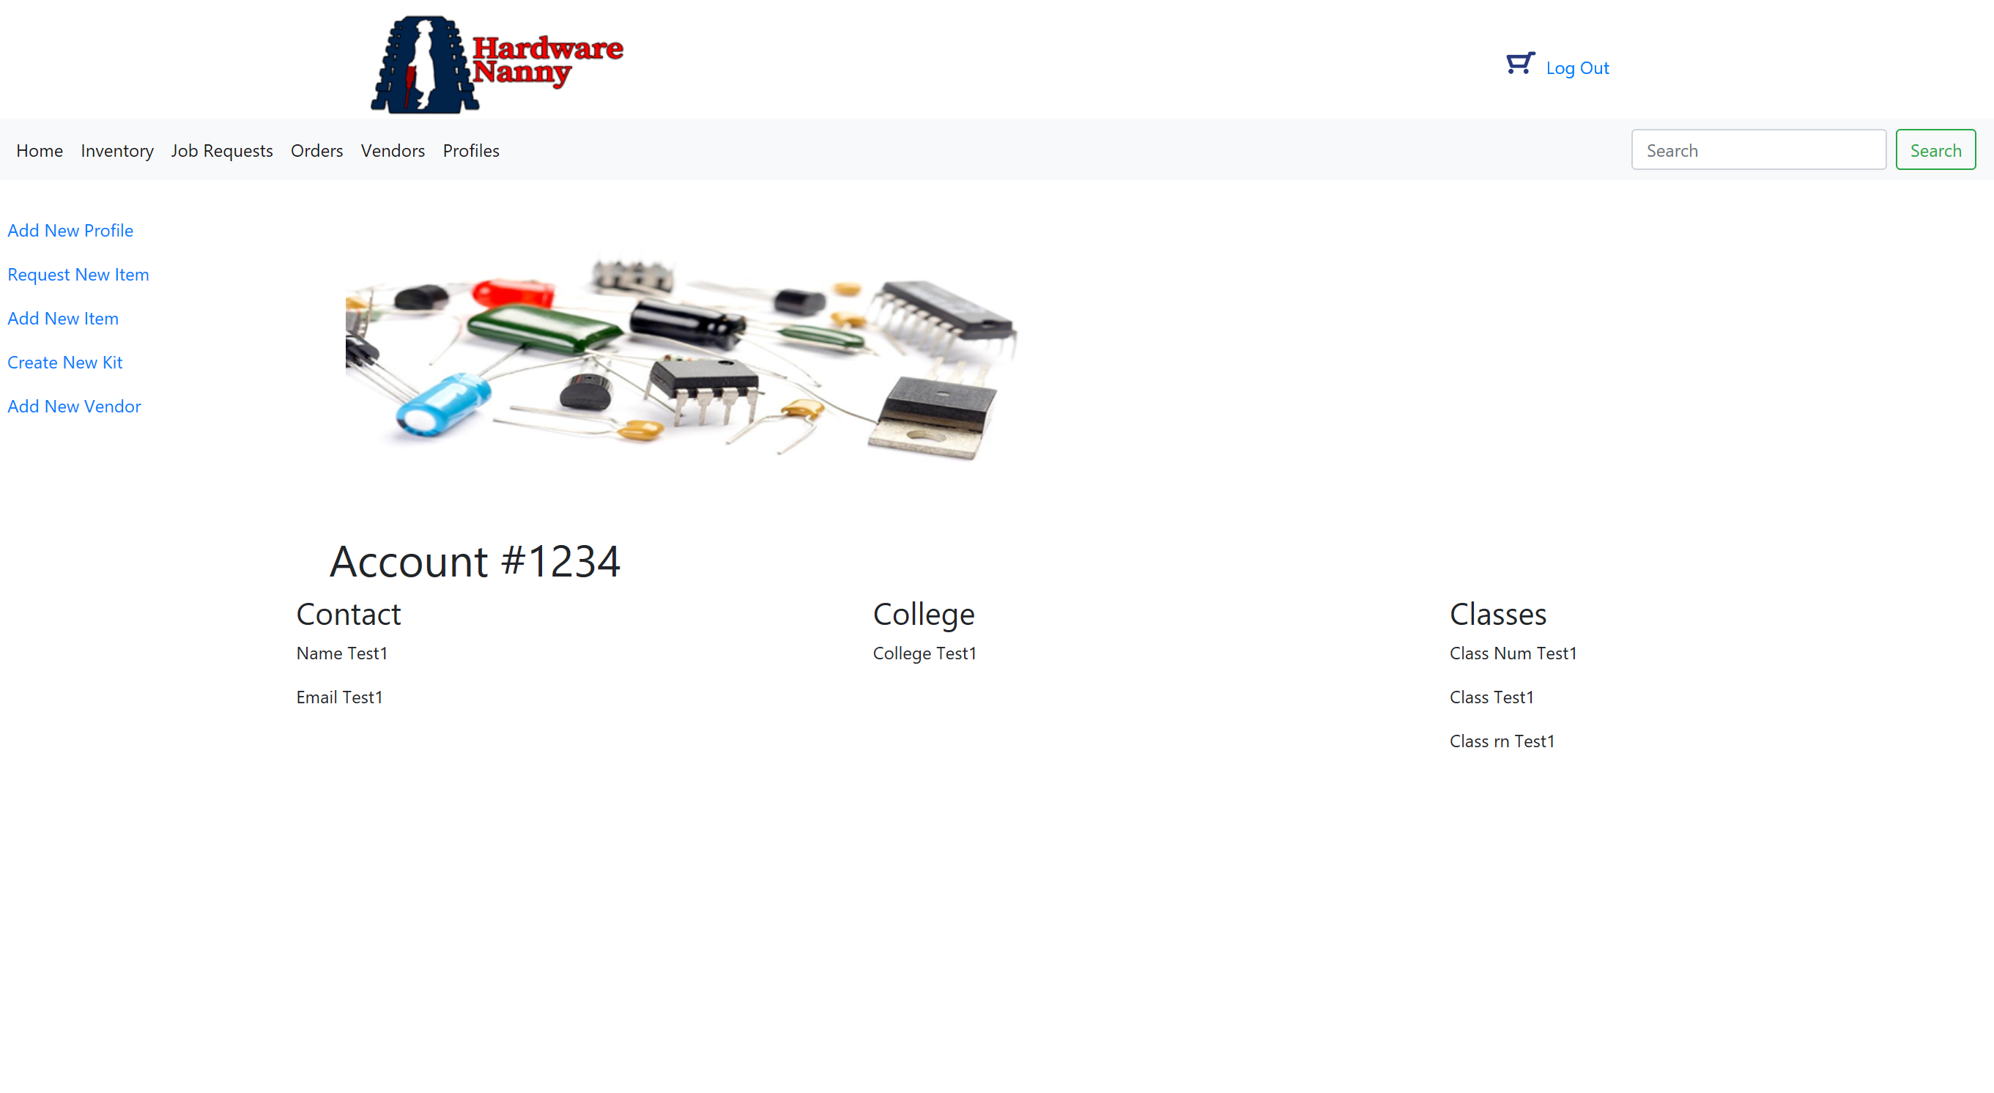

1. **View Inventory**
2. View the inventory items on the inventory page
3. View a specific part click the green View button in the inventory page for the item you wish to view

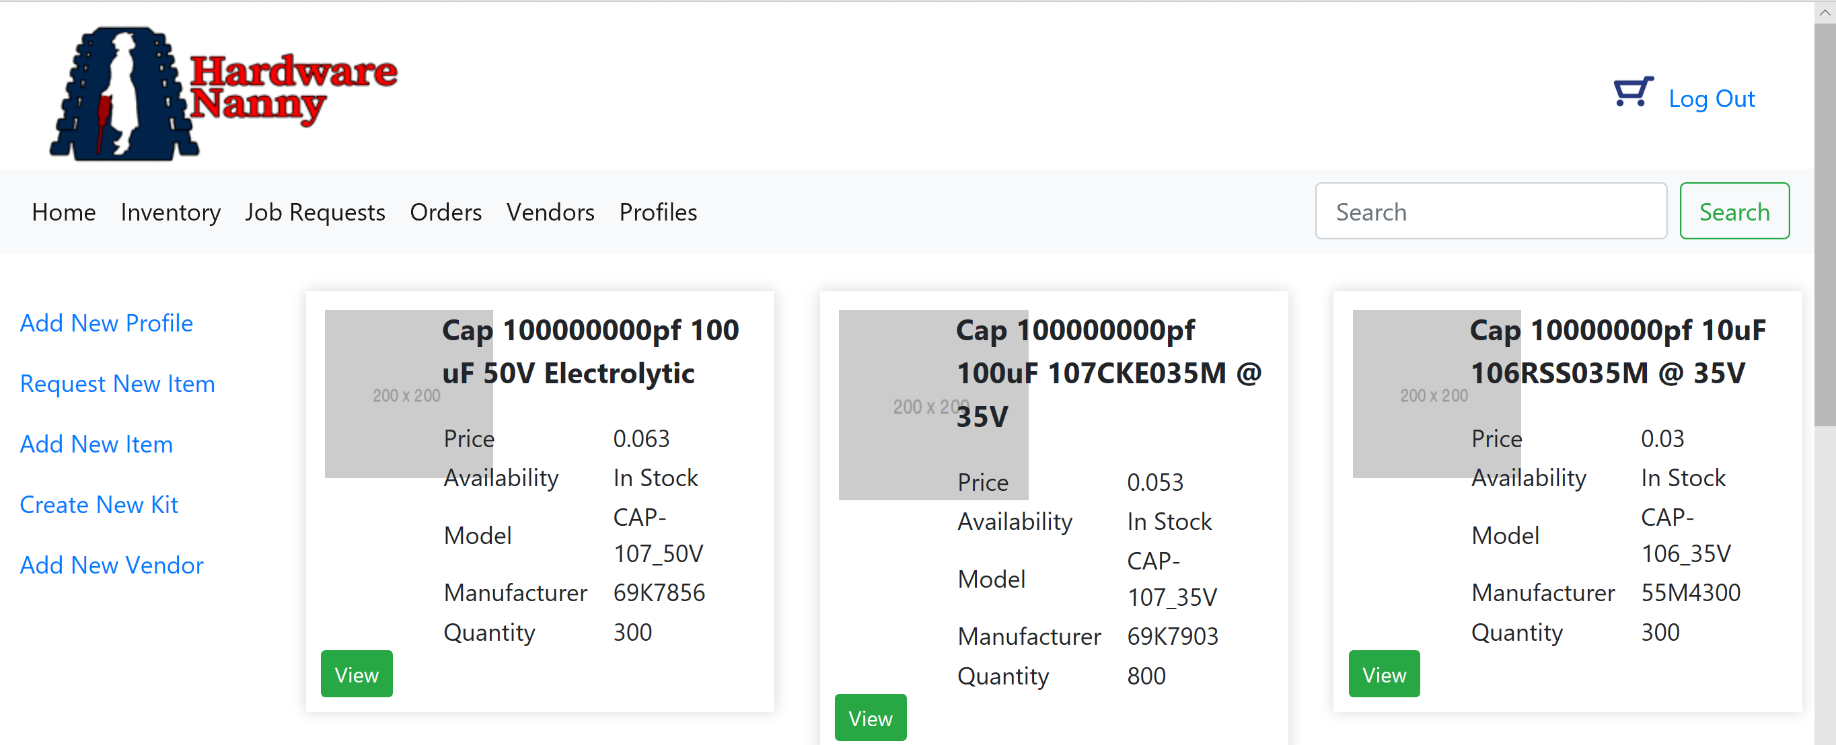

1. Review the inventory item

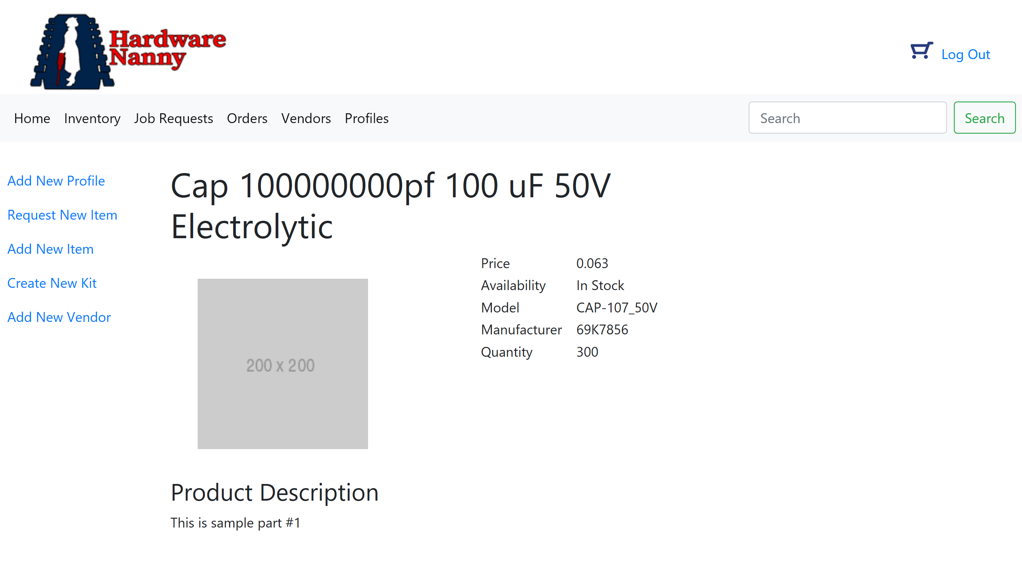

1. **Add New Item to Inventory** 
   1. Click on the Add New Item on the left side bar



b.) Fill out all field sections

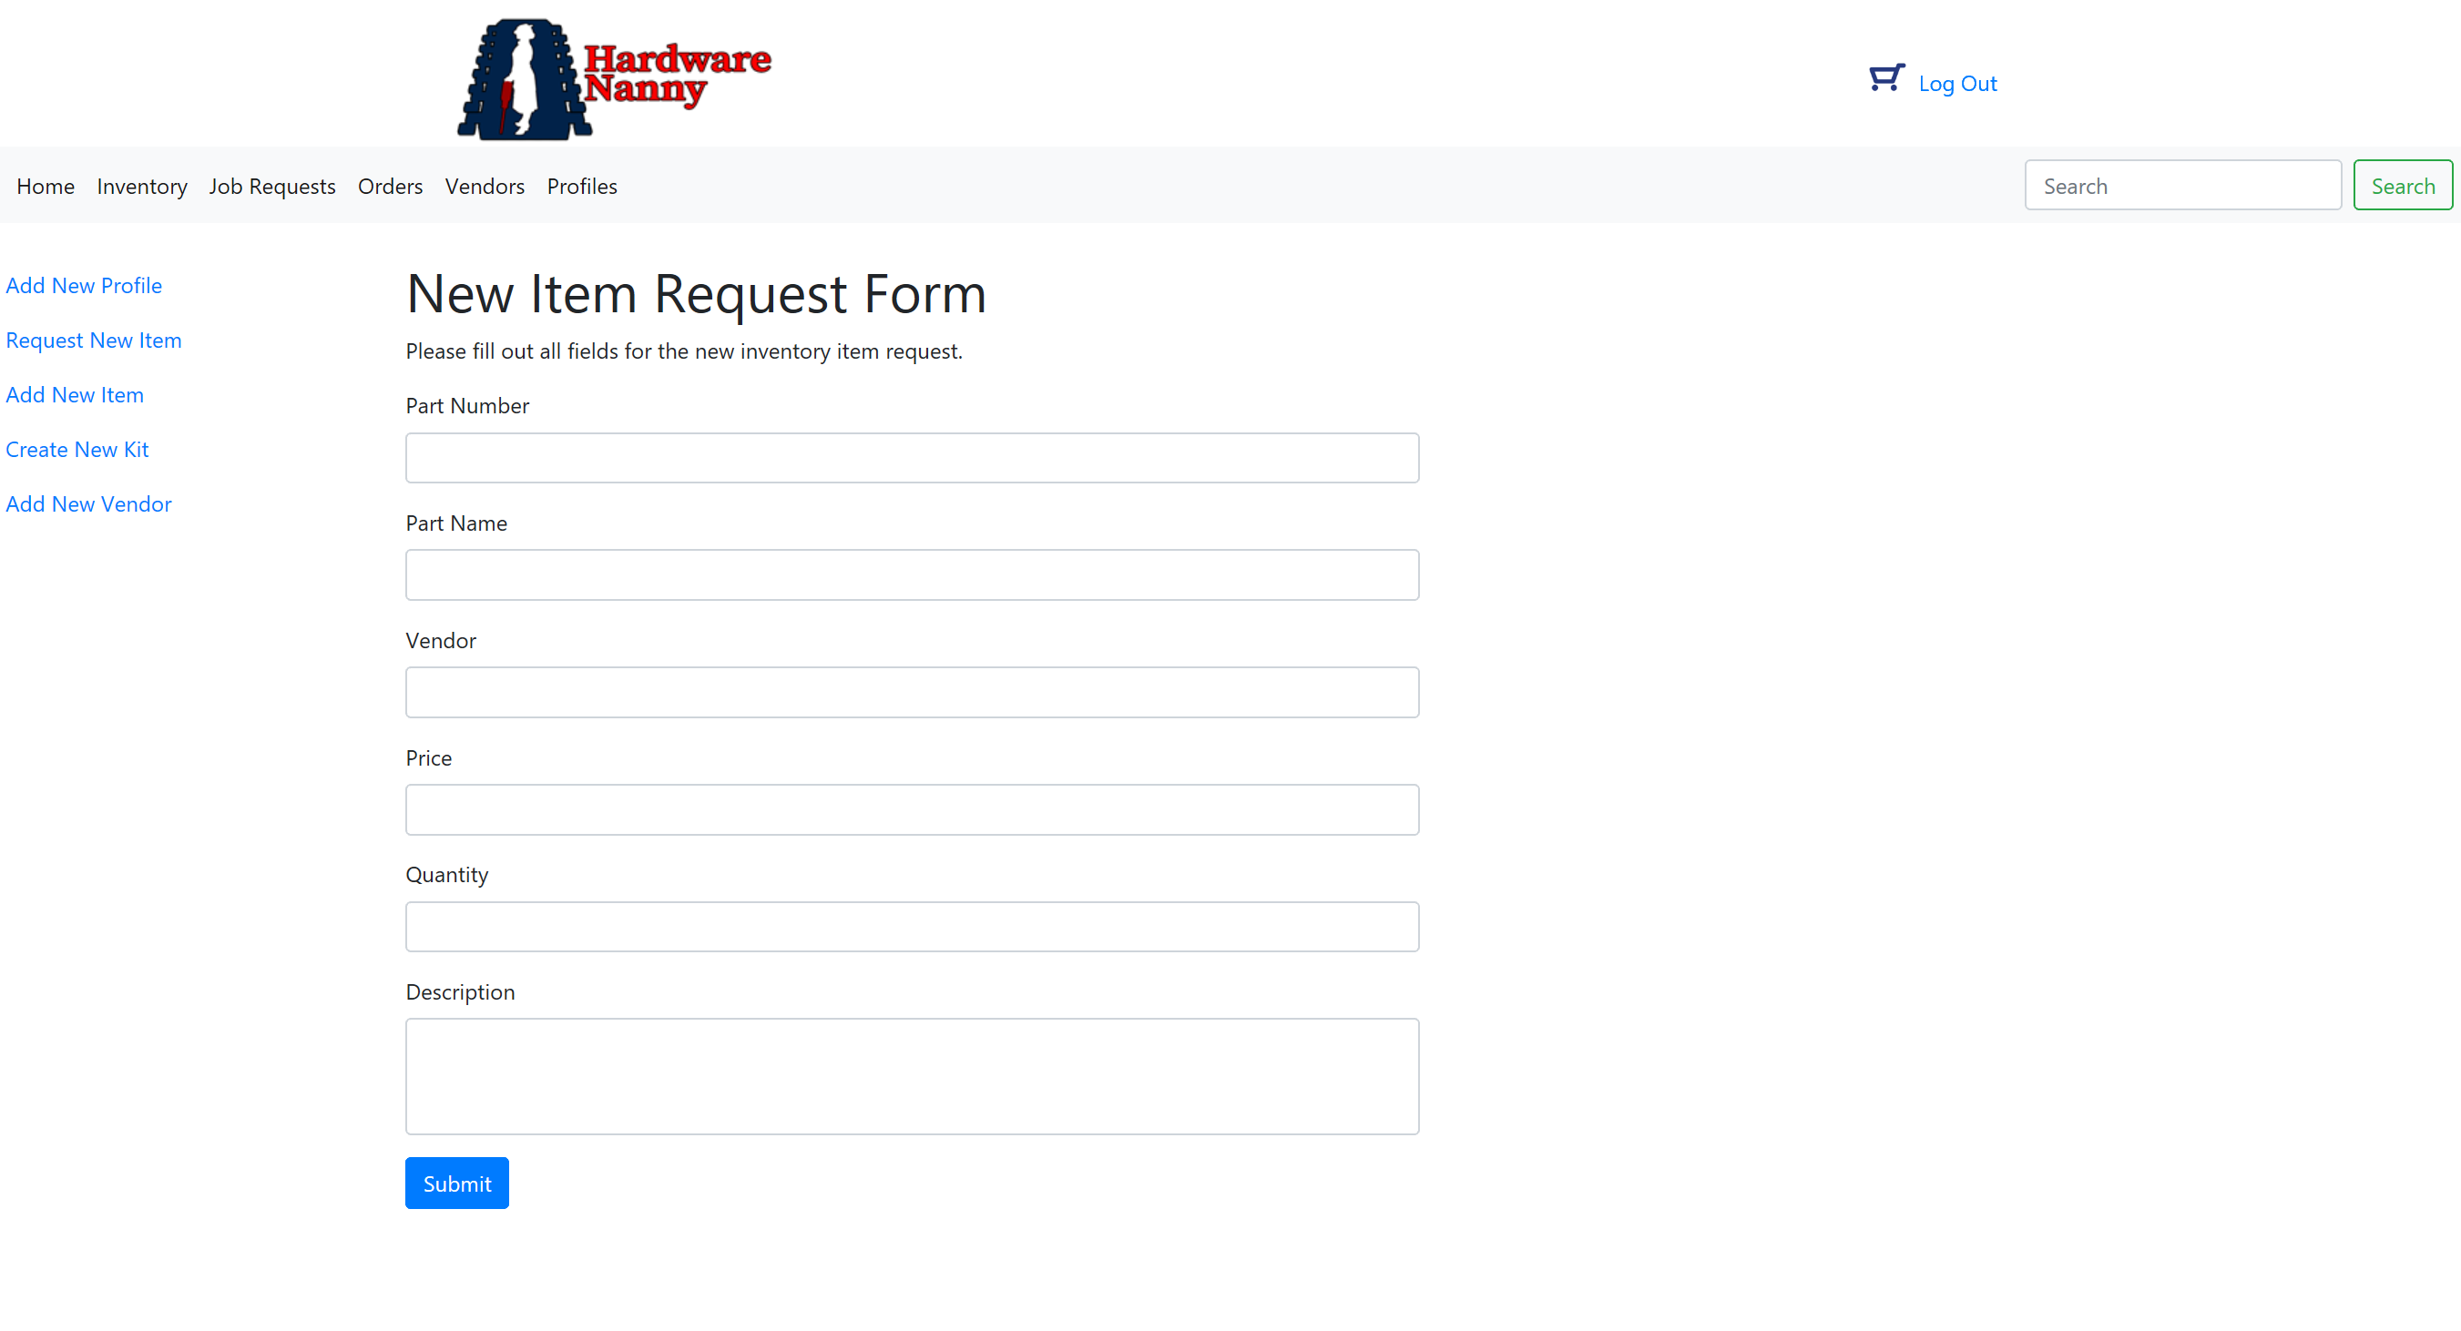

c.) Click submit as shown below

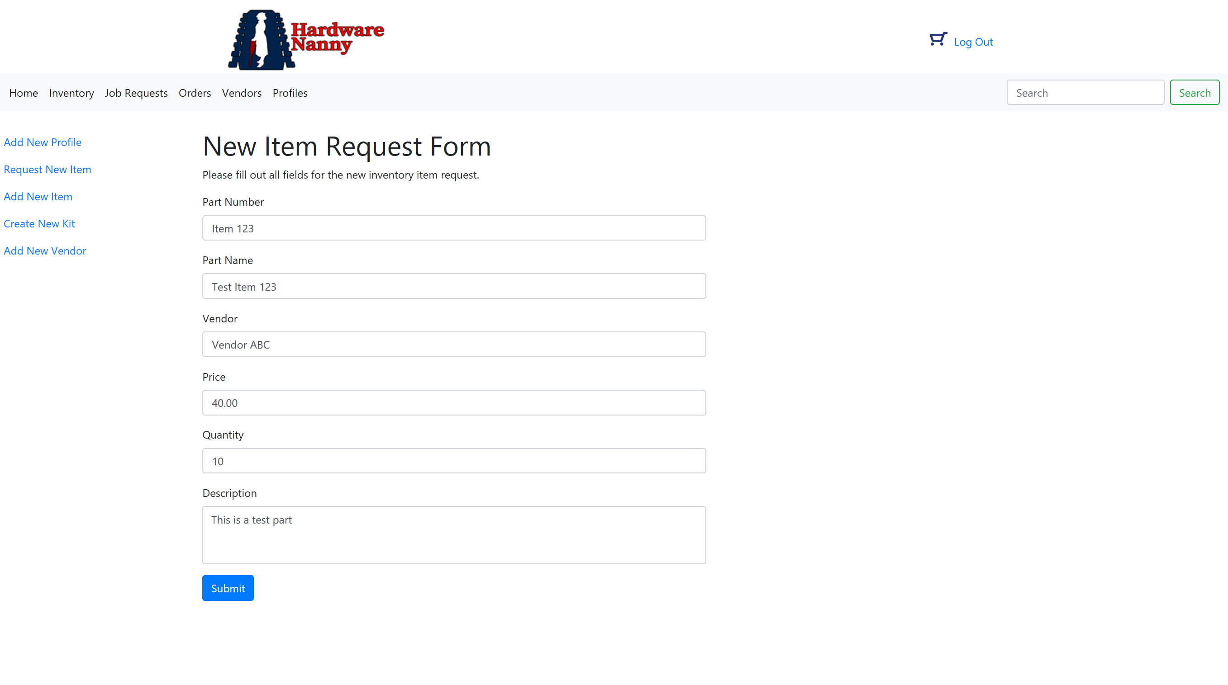

d.) See the new created Item

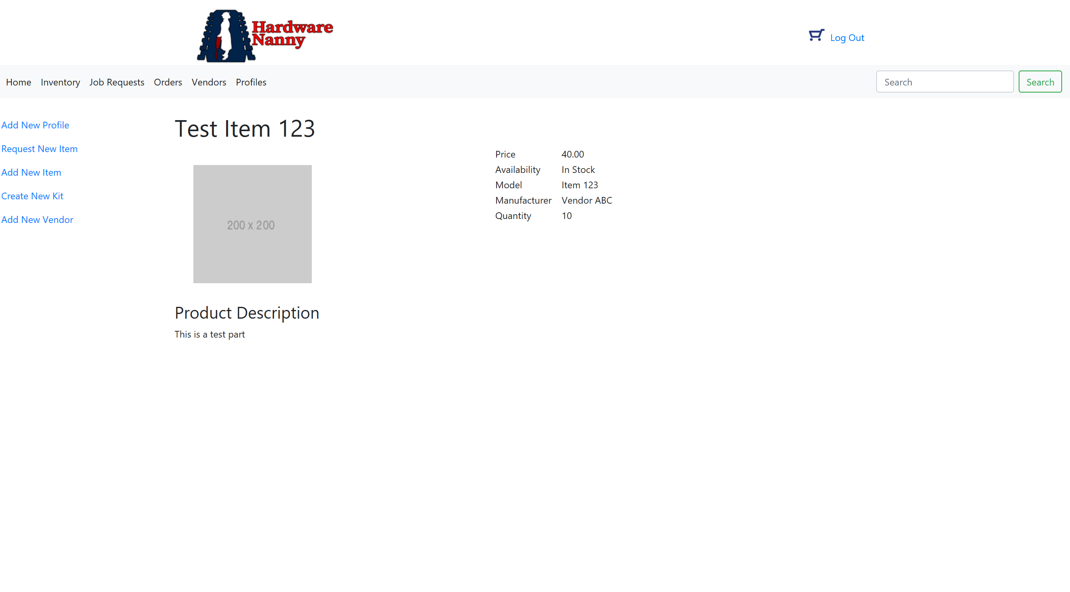

1. **Review new Item in Inventory**
2. See that the New Inventory Item exists in the current Inventory page
3. Optional- click Inventory to view again
4. Logout

